**Can I Get a Rick Flair?  
Whoooooooo!**

**RULES:** Practical Shooting Handbook, Latest Edition **COURSE DESIGNER:** Ike Starnes

|  |  |
| --- | --- |
| **START POSITION: See written stage briefings.** | |
| **STAGE PROCEDURE**  See WSB. | **SCORING**  **SCORING:** See WSB.  **TARGETS:** See WSB.  **SCORED HITS:** See WSB.  **START-STOP:**  Audible - Last shot  **PENALTIES:** Mike -10, NS -10, Procedural -10 |

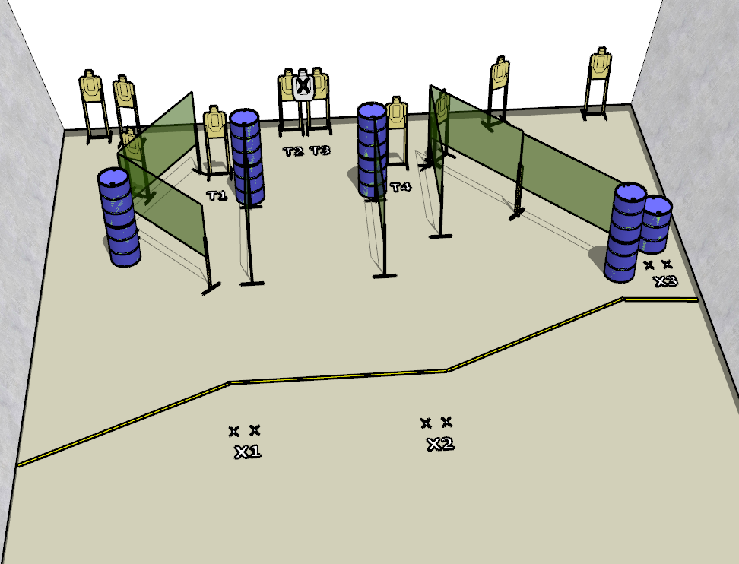

**Written Stage Briefings:**

**Stage 1 –** is a 16-round, 80 point, **Virginia** **Count** Medium Course. There are 4 cardboard targets. The best 4 hits per cardboard target will be scored.

**String 1**

**Handgun start position:** Both feet X1 with wrists below belt. The handgun is **loaded** and holstered.

**PCC start position**: Both feet on X1. PCC is **loaded** with buttstock on belt with muzzle pointed downrange.

On the audible start signal, engage targets T1 – T4 with **only 2 rounds** each from within the shooting area.

**String 2**

**Handgun start position:** Both feet X2 with wrists below belt. The handgun is **loaded** and holstered.

**PCC start position:** Both feet on X2. PCC is **loaded** with buttstock on belt with muzzle pointed downrange.

On the audible start signal, engage targets T1 – T4 with **only 2 rounds** each from within the shooting area.

**Stage 2 –** is a 20-round, 100 point, **Comstock** Medium Course. There are 10 cardboard targets. The best 2 hits per cardboard target will be scored.

**Handgun start position:** Anywhere with wrists above respective shoulders. The handgun is **loaded** and holstered.

**PCC start position:** Anywhere with strong hand wrist above shoulder. PCC is **loaded** with buttstock on belt with muzzle pointed downrange.

On the audible start signal, engage targets from within the shooting area.

**Stage 3 –** is a 20-round, 100 point, **Comstock** Medium Course. There are 10 cardboard targets. The best 2 hits per cardboard target will be scored.

**Start position:** Both feet on X3.

**Firearm** is **unloaded** and placed on barrel with trigger guard over mark.

On the audible start signal, engage targets from within the shooting area.